**ASSOC**

The batch command ASSOC associates a file extension with a file type, or list all associations.

**Example**

@echo OFF

ASSOC | find ".txt"

pause

**Output**

.txt = textfile

As shown in above output, it displays the file association for .txt extension.

If only ASSOC is written and executed, it will display all the file associations for every extension, instead of just .txt extension.

**ATTRIB**

The batch command ATTRIB is used to display the [file attributes](https://en.wikipedia.org/wiki/File_attribute) or set an attribute to a file in the working directory.

**Example**

Now let us suppose we have a file note.txt in our working directory. We will display its file attributes and then make it hidden and read only by adding 'ah' and 'r' attributes to it. And finally, we will remove some attributes we added as well.

@echo OFF

:: To display attribute of note.txt

ATTRIB note.txt

:: To make it read only by adding 'r'

ATTRIB +r note.txt

ATTRIB note.txt

:: To make it hidden by adding 'ah'

ATTRIB +ah note.txt

ATTRIB note.txt

:: To remove attribute read only

ATTRIB -r note.txt

ATTRIB note.txt

**Output**

A note.txt

A R note.txt

A R AH note.txt

A AH note.txt

Here in this output, A means *Archived*, R means *Read only* and AH means *Hidden* file.

**CD**

The batch command CD helps in navigating through different directories and changing directories or displaying current directory.

**Example**

@echo OFF

:: CD without any parameters displays the current working directory

CD

:: Changing to the parent directory one level up

CD..

CD

:: Changing the path to Programs

CD\Programs

CD

pause

**Output**

C:\Users\abc

C:\Users

C:\Programs

**CHKDSK**

The batch command CHKDSK is used for checking error in the disk.

**Example**

@echo OFF

CHKDSK

**CHOICE**

The batch command CHOICE provides a list of options to the user.

**Example**

@echo OFF

ECHO You want coffee?

ECHO Enter Y for yes

ECHO Enter N for no

CHOICE /c YN /m "Yes or No"

**Output**

Now that script will produce following output.

You want coffee?

Enter Y for yes

Enter N for no

Yes or No [Y,N]?

Now the console waits for your input and once you enter your answer it will terminate.

**CLS**

The batch command CLS clears the screen.

**Example**

@echo OFF

CLS

pause

This command just clears all the logs in command prompt screen.

**CMD**

The batch command CMD invokes a new command prompt window.

**Example**

@echo OFF

CMD

**COMP**

The batch command COMP compares the size of two files and checks if they are different in size.

**Example**

@echo OFF

COMP C:\abc.txt C:\xyz.txt

**CONVERT**

The batch command CONVERTS the volumes or drives from one format to another i.e from FAT to NTFS.

**Example**

@echo OFF

CONVERT D:\

**COPY**

The batch command COPY is used for copying files from one location to another.

**Example**

@echo OFF

:: For copying from one drive to another -xyz.txt from D:\ to E:\

COPY D:\xyz.txt E:\

:: If file has whitepace between name - use double quote

COPY "D:\my file.txt" E:\

**DATE**

The batch command DATE displays the current date in the system.

**Example**

@echo OFF

echo %DATE%

**Output**

Fri 07/07/2017

This command DATE displays system date in command prompt as shown above.

**DEL**

The batch command DEL is used for deleting files.

**Example**

@echo OFF

:: To delete a single file xyz.txt

DEL D:\xyz.txt

:: To delete all the files of .txt extensions and ask for confirmation before deleting

DEL /p/s D:\*.txt

:: Remove \p to delete without confirmation

DEL /s D:\*.txt

**Note:** DEL command only deletes files, not directories.

**DIR**

The batch command DIR lists all the contents of directories.

**Example**

@echo OFF

:: To list all the contents of current directory

DIR

:: To list all the hidden files of working directory

DIR /ah

:: To list all files with .php extensions

DIR *.php

**DISKPART**

The batch command DISKPART shows the properties of a disk partition.

**Example**

@echo OFF

DISKPART

This script will ask for users permission to check the properties of disk partition and if allowed, will display following output in the console depending on disk properties.

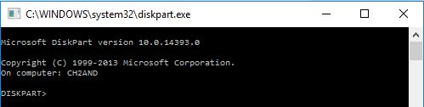

**DRIVERQUERY**

The batch command DRIVERQUERY displays all the drivers installed and their properties.

**Example**

@echo OFF

DRIVERQUERY

**Output**

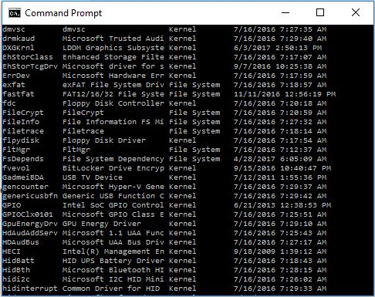

This output shows the fraction of drivers list with their properties and installed date. DRIVERQUERY command shows all the drivers list, which is huge.

**ECHO**

The batch command ECHO is used for echoing commands on/off and printing message to the console.

**Example**

@echo OFF

echo Hello

**Output**

Hello

This command ECHO displays Hello in the console as shown above.

Besides printing message, echo is also used for deciding whether or not to display the command itself. Like in this example as well, in the first line we have turned OFF echo, which makes sure that commands themselves are not printed.

If that echo wasn’t turned off, then the output would have been like:

C:\> echo Hello

Hello

**EXIT**

The batch command EXIT terminates and exits the console.

**Example**

@echo OFF

echo HI

EXIT

In this example, as soon as HI is printed in the console, EXIT command will terminate the program and close the output console.

**EXPAND**

The batch command EXPAND extracts the contents of .cab file.

**Example**

@echo OFF

EXPAND xyz.cab

This script will extract all the contents of xyz.cab file to the same location where xyz.cab is located.

**FC**

The batch command FC finds the difference between the two files and displays them to console.

**Example**

@echo OFF

FC D:\a.txt D:\b.txt

This script will find the difference in the content of both files and list out all of them.

**FIND**

The batch command FIND search the given file to find the desired string and if located, it displays the corresponding line in which the string exists.

**Example**

@echo OFF

FIND "find me" example.txt

This script will search for the string “find me” in example.txt file and if it exists in example.txt, it will display the corresponding line on the console.

**FORMAT**

The batch command FORMAT is used for formatting a drive of format FAT 16/32 or NTFS in Windows.

**Example**

@echo OFF

FORMAT E:\

This script will format E drive and overwrite previous contents.

**HELP**

This might be the one of the most important batch file commands because with this HELP command we can know about all the other commands used in batch file or command prompt.

**Example**

@echo OFF

HELP

Now this will display all the available commands with their functionalities in the console.

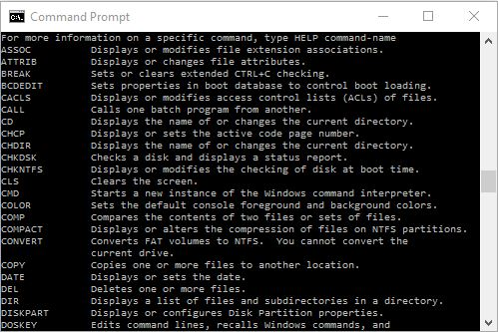

Since the list of commands is so much more, we have sliced the list and shown few here.

Now that we have a list of batch file commands, we can also view details of their syntax and functionalities in following way:

@echo OFF

:: Just type help and the command you want to know about

HELP copy

Now this will display details of the copy command.

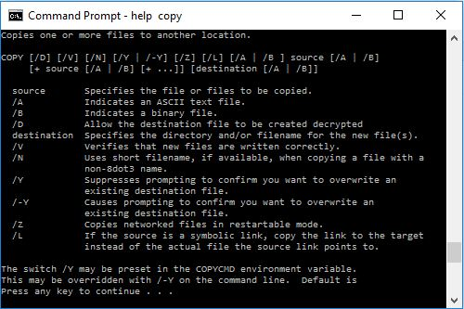

As you can see, it HELP COPY displays all the details about COPY command.

**IPCONFIG**

The batch command IPCONFIG displays Windows IP configuration.

**Example**

@echo OFF

IPCONFIG

This script will generate following output.

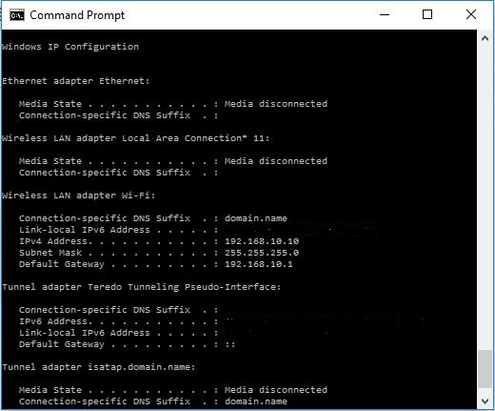

P.S: We have hidden iPV6 address in above output.

**LABEL**

The batch command LABEL displays the label of a drive or volume and is also is used for adding, setting or removing a disk label.

**Example**

@echo OFF

LABEL

Now this will display the label of your working directory and you can set, remove or add another label.

For example, my working directory is D: and has label ‘apps’. So, it will generate following output:

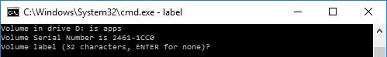

**MD**

The batch command MD creates a new directory or folder in the working directory.

**Example**

@echo OFF

MD abc

This program will create a new directory abc in current working location.

**MORE**

The batch command MORE displays the content of a file one by one.

**Example**

@echo OFF

MORE D:\example.txt

This program will display the contents of example.txt line by line, one at a time.

**MOVE**

This batch command moves files from one directory to another, rename the directories and move the directories as well.

**Example**

@echo OFF

:: To move xyz.txt from dir1 to dir2

MOVE C:\dir1\xyz.txt C:\dir2

:: To rename directory dir1 to dir2

MOVE C:\Program\dir1 C:\Program\dir2

:: To move directory dir1 from D:\ to D:\music

MOVE D:\dir1 D:\music\

In this way, MOVE command can be used to move files, directories and rename directories.

**NET**

The batch command NET is used for many network functionalities depending upon the commands used.

**Example**

To display the users:

@echo OFF

NET users

This will generate following output:

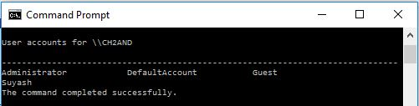

Like users, there are many other commands:

* net accounts
* net computer
* net config
* net continue
* net file
* net group
* net help
* net name
* net pause
* net print
* net send
* net session
* net share
* net start
* net statistics
* net stop
* net time
* net use
* net view

**PATH**

The batch command PATH displays the path variable or it can be used to set path variable.

**Example**

@echo OFF

ECHO %PATH%

This program will display the path of the current working directory.

**PAUSE**

The batch command PAUSE is used for holding the output screen till user enters a variable or a value.

**Example**

@echo OFF

ECHO hi

pause

This program will print *hi* in the console and show the message ‘Press any key to continue..’ and wait for the input from the user.

**PING**

The batch command PING is used for sending ICMP/IP packets to the designated address over the network.

**Example**

@echo OFF

PING 127.0.1.1

**Output**

This script will send packets to address 127.0.1.1 and output will be displayed as follows:

Pinging 127.0.1.1 with 32 bytes of data:

Reply from 127.0.1.1: bytes = 32 time<1ms TTL = 128

Reply from 127.0.1.1: bytes = 32 time<1ms TTL = 128

Ping statistics for 127.0.1.1:

Packets: Sent = 2, Received = 2, Lost = 0 (0% loss),

Approximate round trip times in milli-seconds:

Minimum = 0ms, Maximum = 0ms, Average = 0ms

**RD**

The batch command RD is used for removing the empty directories, directories with contents or files inside cannot be removed with RD command.

**Example**

@echo OFF

:: To remove directory xyz from C:\>

RD C:\xyz

:: To remove multiple directories from working location

RD dir1 dir2

**REM**

The batch command REM signifies comments in the batch script.

**Example**

@echo OFF

REM This is a comment

Anything written after REM is interpreted as a comment and is not executed in batch programs.

**REN**

The batch command REN is used for renaming files and directories.

**Example**

@echo OFF

:: To rename x.php to y.php

REN C:\x.php C:\y.php

**SET**

The batch command SET displays the list of environment variables of the system.

**Example**

@echo OFF

SET

**SHUTDOWN**

The batch command SHUTDOWN when invoked, shuts down the computer.

**Example**

@echo OFF

SHUTDOWN

**SORT**

The batch command SORT is used to sort the content of the file alphabetically.

**Example**

@echo OFF

SORT D:\example.txt

This script will sort the content of example.txt alphabetically either in ascending or descending order.

**START**

The batch command START is used to open a file or start a new program.

**Example**

@echo OFF

START paint.exe

This program will start the application paint if it is in the working location, else you will have to explicitly indicate the path of that program as well.

**SYSTEMINFO**

The batch command SYSTEMINFO displays all the configuration of the computer and operating system.

**Example**

@echo OFF

SYSTEMINFO

This will generate following output depending upon the computer:

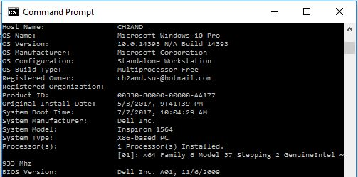

Of course, the details will be much more than this, but please try and look on your PC.

**TASKKILL**

The batch command TASKKILL is used to terminate a running task

**Example**

If you were to terminate the notepad running in your PC, then following script is used.

@echo OFF

TASKKILL /im notepad.exe

**TASKLIST**

The batch command TASKLIST lists all the running tasks in the console.

**Example**

@echo OFF

TASKLIST

**TIME**

The batch command TIME is used to display or set the system time.

**Example**

@echo OFF

ECHO %TIME%

**Output**

18:01:22:06

The current time is displayed in the console.

**TITLE**

The batch command TITLE sets new title for output console.

**Example**

@echo OFF

TITLE New Console

This script will set the title of output console to ‘New Console’. Thus the output console will look like:

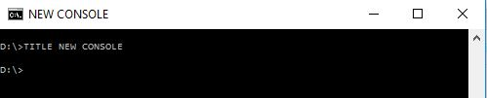

**TREE**

The batch command TREE displays the tree diagram of the subdirectories to the last level.

**Example**

I have a  folder movies. SO, if I were to run TREE in that movie folder, it will create a tree of movies inside that folder and also the subdirectories where there is movie file and subtitle file.

@echo OFF

TREE D:\movies

**Output**

This script will generate following output.

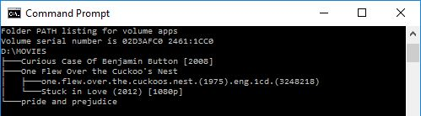

**TYPE**

The batch command TYPE is used for displaying the content of a file to an output console.

**Example**

@echo OFF

TYPE C:\notes.txt

pause

This program will display all the contents of notes.txt to the console.

**VER**

The batch command VER displays the version of Windows or MS-DOS.

**Example**

@echo OFF

VER

pause

**Output**

Microsoft Windows [Version 10.0.14393]

**VOL**

The batch command VOL displays the current volume label of Windows.

**Example**

@echo OFF

VOL

**Output**

Microsoft Windows [Version 10.0.14393]

**XCOPY**

The batch command XCOPY is similar to COPY command but COPY command copies single file whereas XCOPY command copies entire directories including subdirectories.

**Example**

@echo OFF

XCOPY D:\test.txt to E:\

This script will copy test.txt from D drive to E drive.

So, these are the batch file commands along with examples.

We hope you find these batch file commands easy to learn. We will discuss more advanced concepts in next tutorials.